5 Tips for Staying Productive While You're Working from Home

Location, Location, Location

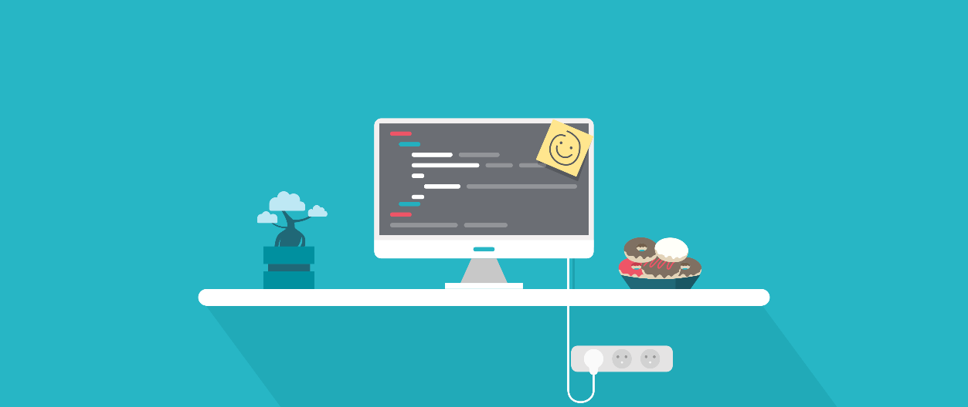
Try to find yourself a dedicated and comfortable spot to work that you can associate with your job and leave when you’re off the clock — that means get off the couch, and definitely out of bed.
“It definitely helps if you have a dedicated space for working from home,” says remote worker Matt Haughey, creator of the long-running community weblog MetaFilter, and writer for Slack. “I started doing this kind of work sitting at a desk in the middle of my living room of a small San Francisco apartment 20 years ago, and it was a pain to stay on task and not get interrupted.”
Since then, Haughey has set up a dedicated home office where he can close the door and shut out distractions. He has also gone to local libraries to take advantage of their free Wi-Fi — but given that today’s work from home recommendations are meant to prevent spreading COVID-19, heading out into a public place is likely counterproductive.

Find a Buddy
You might find it easier to be productive without your most chatty coworkers constantly buzzing in your ear. But social interactions — even with coworkers — can alleviate feelings of isolation and loneliness. Durham University’s Dr. Thuy-vy Nguyen, who studies the effects of solitude, thinks the psychological effects of working remotely for extended periods is often overlooked or ignored, despite it being an essential factor in our mental well-being and team bonding.
“We’re used to social interaction,” she says. “It facilitates cooperation and closeness.”
To help fill the socializing gap while working remotely, Nguyen recommends finding a colleague you can hit up when you’re feeling the need to chat with someone. Alternatively, buddy up with a friend who works elsewhere and is going through the same experience. Hopping on a social video call instead of Slack or text isn’t a bad idea, either.

Have a Plan
Nguyen also recommends that, when working alone, you should keep a more structured daily schedule than usual.
“Usually our time and the structure of our day are influenced by other people,” she says. “You’re going to experience your day as lacking the normal structures that you usually have. People might have a hard time dealing with it. So one of the things that we found in our trying to understand solitude, is that time spent alone is better if it’s structured.”
For Haughey, his schedule includes multiple breaks throughout the day, either to play with his dog or take a long walk around the neighborhood and grab the day’s mail.

Think About How You’re Communicating
Haughey says it’s important to go beyond email and use other digital tools that can better replicate the in-person office experience and provide for clear communication.
“There will be a sense of isolation of course, and it depends on how well your team communicates, or how much they’re willing to amp up communication using other tools besides face-to-face conversations,” he says. He communicates with his team using chat apps like Slack and videoconferencing services like Zoom. “Screen-sharing is another killer aspect of getting people on the same page,” he adds. “If I’m in a meeting to give feedback, chances are the host is sharing their screen as well so we’re all looking at the same thing as we toss ideas around.”
Harvard Business School’s Prithwiraj “Raj” Choudhury, who studies remote work and the relationships between geography and productivity, found an interesting solution to boosting camaraderie among remote workers: pizza parties. While researching remote work habits at the U.S. Patent Office — which implemented a more robust “work from anywhere” policy in 2011 — Choudhury discovered a manager who hosted weekly lunches via videoconferencing.
“She would order the exact same pizza to be delivered at the same time so the team would have that bonding experience and still feel like a team,” says Choudhury. “This is the future of work, so we cannot just keep doing stuff in the old familiar ways, we have to create new processes.”
Furthermore, better communication while remote can help maintain your relationship with your colleagues, managers, and direct reports. It’s also important for managers to encourage employees to share their opinions or concerns about a particular project so they don’t feel like they’re being dismissed just because they’re not in the same room.

Remember Everyone Works Differently
Managers should remember that not every employee actually wants to work from home, a shift that can be stressful for some. As companies increasingly mandate that many employees must work from home during the coronavirus outbreak, it’s key they communicate as much as possible and help employees struggling with the change, says Nguyen.
“If management actually forces people to stay at home, then that would add another layer of stress,” she says. “Giving employees as much information as possible can ease the burden caused by the disruption.”
If you are struggling with the change from office to remote, talk with your supervisor or a work colleague.

