Insights on How to Prevent Social Distancing from Becoming Social Isolation
The concurrent practice of social distancing is essential in helping to stop the virus. But without the ability to socialize, participate in school and work activities, go to restaurants, and attend events, people might feel social distancing is quickly turning into social isolation.
Here are some ways to counteract the digression:
Prioritize virtual connections
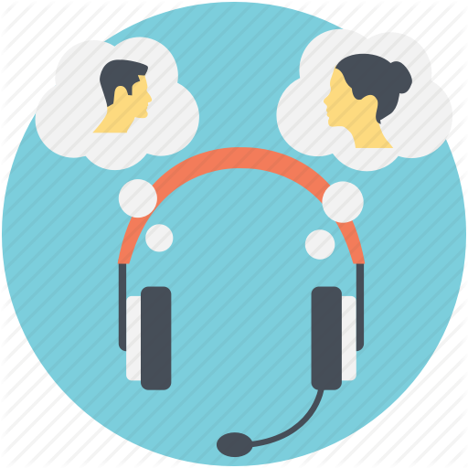
Office conversations, hallway chats, and breakroom banter—they’re all typical in shared work environments. When those environments become home offices, however, the connections fostered by these kinds of communication can easily weaken.
Schedule video meetings or online chats with colleagues to preserve the fun exchanges. Don’t set a formal agenda or specific purpose—just focus on creatively maintaining interpersonal relations.
Share your working space
Remote workers may find the company of their colleagues in Zoom Rooms an effective remedy to loneliness. These virtual office spaces allow teammates to work together without the need to actively interact.
Zoom, Skype, Google Teams and other online video conferencing tools let employees across the globe gather with video on and sound off while they work on their own tasks for the day. The intention isn’t to discuss projects, but rather, to foster a sense of camaraderie that replaces the missing office connections.
Use social channels to stay connected
Too much social distance can contribute to poor emotional or mental health, and physical isolation can significantly worsen these concerns. However, new technology is shortening the distance by allowing people to stay connected in inventive ways.
The social messaging platform TikTok has seen an increase in new users during the past two months. And Netflix Party is a recent addition that allows groups of friends to watch the same movie or TV show, while allowing interaction and chat. Consider these options and traditional social channels to interact with friends, family, and coworkers.
Develop a routine when possible
It’s important to clearly separate work and home responsibilities, especially if children are home from school. To reduce feelings of becoming a shut-in, create a dedicated workspace and stick to normal working hours. Close your computer at the end of the day, and don’t return to the workspace until the following day. This routine will help you avoid feeling endlessly trapped at work.
Protect your physical health
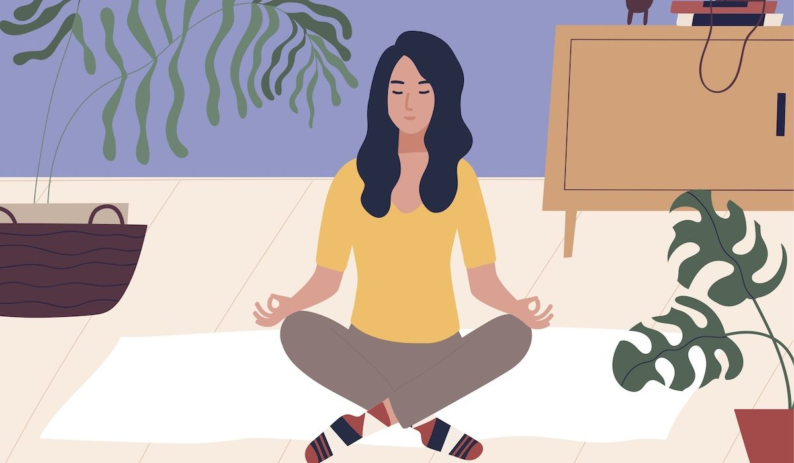
Keep up on health and wellness, while fitting in physical exercise to reduce any anxiety and depression. Most gyms are temporarily closed, but you can take streaming fitness classes and group exercises. Even online health portals can encourage activity among a group of employees while promoting a sense of community.
If your employer offers health coaching now is the perfect time to connect with a health coach. Technology has helped people more easily access coaches—beyond the phone, with options like video conferencing and direct messaging through wellness platforms. They can offer personalized recommendations to keep participants motivated and focused on their well-being during this trying time.
Working in a home office will continue to be the new norm for many people during the COVID-19 pandemic. It may provide some comfort to know that thousands of other people are going through the same transition. By taking proactive steps to stay connected, prioritizing health and well-being, and addressing states of isolation, you can come out of this feeling more connected to each other than ever before.

