Simple Ways to Preserve Your Health as a Remote Worker
The worldwide pandemic of 2020 has dramatically changed our lives in the past few weeks, creating a new way of working and living. During these times of sudden change and uncertainty, the best way to navigate the new changes is by focusing on self-care and helping those around you while following proper health precautions. It‘s also an important time to bring your health and well-being to the forefront.
Self-care in the wake of the coronavirus outbreak includes focusing on things you can control (like having good hygiene) instead of those you cannot (stopping the virus). Below are some simple steps to help focus on well-being while you adjust to a new normal, and changes to your daily routine:
Go for a walk in your neighborhood
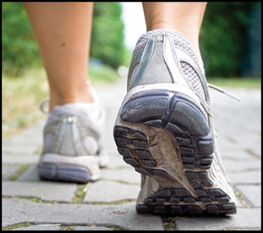
Participating in outdoor activities is perfectly acceptable if you maintain a distance from others of at least 6 feet. Going for a walk, visiting a local park, or even playing in the yard with your children are great ways to incorporate physical activity into your new routine. Taking a break to exercise can also help reduce stress.
Take an online fitness class
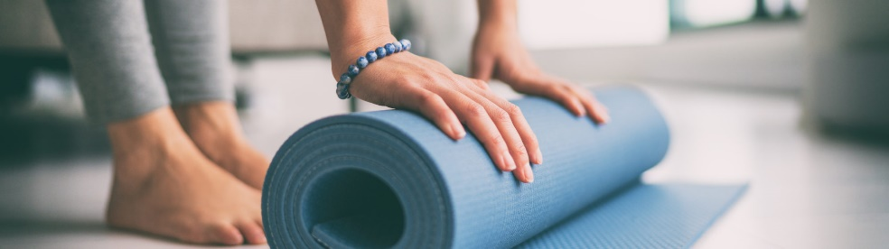
Many fitness companies, personal trainers, and health organizations are making on-demand. If you’ve been curious about trying a Zumba class or want to get back into yoga, now is a great time to do so. There are numerous exercise routines that require no equipment other than internet access.
Have a virtual book club with friends
While gathering a group of friends may not be possible right now, you can still connect with a virtual meet-up. If you have a weekly gathering or book club meeting, use FaceTime or another video streaming service to connect with your group. Maintaining these events, especially during uncertain times, will help keep a sense of normalcy.
Talk to a counselor or therapist

If you are feeling overwhelmed or concerned about how to handle social isolation, it’s okay to reach out for help. Many employees have EAP plans that include free or discounted counseling sessions that can be conducted virtually or over the phone. McPherson College’s Employee Assistance Program’s brochure may be accessed at: https://wwwi.mcpherson.edu/wp-content/uploads/2020/04/EAP-Brochure-4.2020.pdf
It may even help to talk with a close friend about your concerns and how you are feeling. We’re all in this together.
Try new healthy recipes
With extra time being spent inside, now is a great time to focus on healthy eating. Use this time to invest in trying new healthy dishes and become more mindful of how you nurture your body. During quarantine it can be natural to stress eat or crave comfort foods, but being aware of how you’re eating can help maintain focus on well-being.
Reduce stress
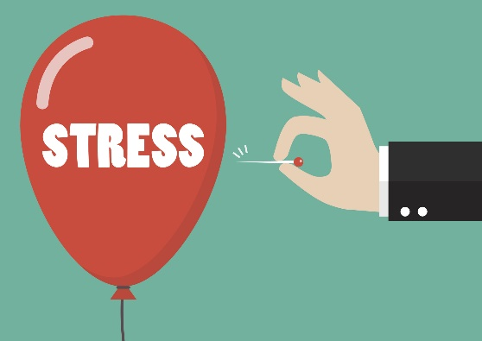
The current information being shared from authorities and news media can be scary and overwhelming. It’s important to take breaks from watching, reading, or listening to news stories, especially on social media. Take time to meditate, read a book, or watch a movie—anything to help you unwind and separate your mind from stressors.
Keep up your daily routine and normal activities as much as possible. Consider creating a schedule that prioritizes your well-being and positive mental health. Even simple activities like exercising or completing a puzzle can help you to relax and positively influence your thoughts and feelings.
Life may feel very hard and stressful over the next several weeks or even months. There are very real burdens, and we won’t always like it. But the pandemic will end eventually. We just need to take precautions to protect our health and well-being in the meantime.

