Supplemental Data for Fact Sheet Title IX for Fall 2021 Workshops

- What’s the big deal?
- Physical Trauma to the body
- PTSD (Post Traumatic Stress Disorder)
- Depression
- Dissociation
- Anxiety
- Sexually transmitted diseases
- Loss of Control and sense of safety/security
- Substance abuse
- Inability to focus on work related duties or to concentrate on school work
- Loss of trust
- Anger and Blame
- Shock, numbness, fear, disorientation, helplessness

- What can I do about it? (prevention piece)
Besides responsible drinking there are other things you can do to be safe:

Say something to a friend. Engage a Buddy System.
Check out the Student Life Bystander Education Program. Call Jamie Pjesky (extention 2604) or Brenda Stocklin-Smith (extension 2454).
Distract from the situation. Deescalate and diffuse difficult situations. Try to redirect people involved.
Tell someone in authority—McPherson PD, an RA or, other Housing staff.
Be aware of clues that things may be getting out of hand or that someone is vulnerable. For instance, raised voices, threats, shoving, pushing or directing someone with force.
Intervene before things get out of hand or someone is hurt.

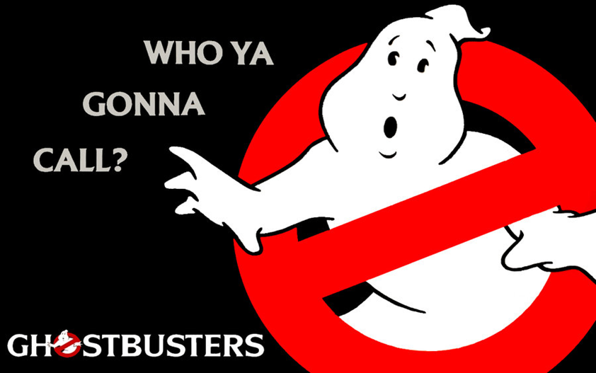

- Call Shana Meyer or Dr. Bruce Clary
- To report a crime, including those of sexual violence call the McPherson Police Department (620-245-1200).
- If it is an emergency call 911

