J1 Web Employee Hub:

All Employee information can be found in J1 Web, which is available to you anywhere, you can get to J1 Web on campus or off campus. The link below will take you to the log in screen.

[**https://mphj1.jenzabarcloud.com/J1Web/Home/Index**](https://mphj1.jenzabarcloud.com/J1Web/Home/Index)

You will use your computer/email login for J1 Web. The username is everything before the @ sign in your email address. This is **not** your bulldog connect login.

Once you log in you will click on the 9 square icon, which will take you to the hub options that are based on your permissions.

Click on the arrow next to HCM, then Employee and then Summary

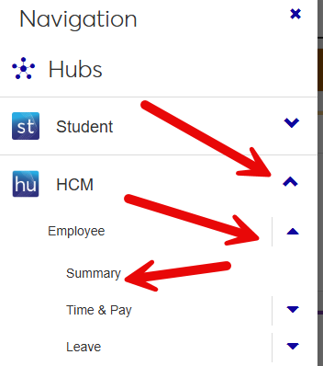

The Employee Hub summary page will open. This Hub shows all of the information related to you as an employee. The Hub options menu drop down will take you to more detail information than is found on the Summary page.

The push pin icon will allow you to ‘Pin’ this page to your home page, which is the first page you come to on sign in. The ‘?’ icon will take you to help for that block on the page.

I would recommend pinning any of the blocks that you might normally go to so they appear on your home page for easy access.

A screenshot of J1Web Home page.


J1 Web Timecard Entry for Student Workers:

Time entry must be done as you work! If you do not clock in when you start working for the day you are not able to go back and enter time later, this will have to be done by your supervisor.

Log onto J1 Web and navigate to the timecard block, if you have pinned the block to your home page you will be able to enter time there, or you will need to navigate to the Employee Hub and then click on Enter time.

When you are starting work, click on the clock in button. When finished working click on the clock out button.

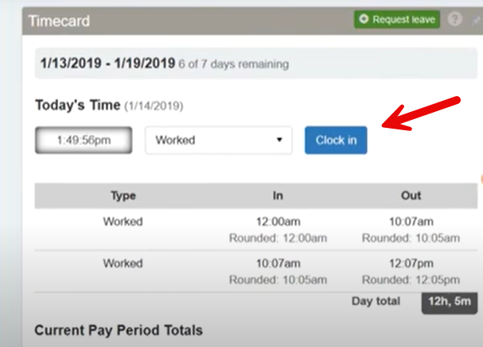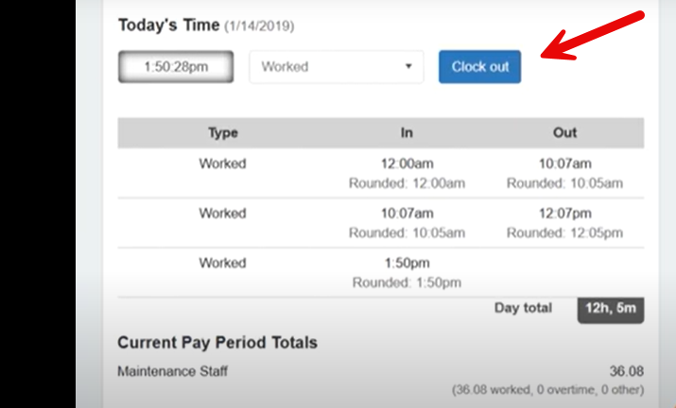

At the end of the pay period. You will need to click the finalize timecard button, you will be presented with a pop up reminder that you are finalizing your timecard and this will lock your timecard for supervisor review.

J1 Web Timecard Entry for Hourly Employees:

Log onto J1 Web and navigate to the timecard block, if you have pinned the block to your home page you will be able to enter time there, or you will need to navigate to the Employee Hub and then click on Enter time.

When you get to the timecard you will enter and start and end time for each day worked.

At the end of the pay period. You will need to click the finalize timecard button, you will be presented with a pop up reminder that you are finalizing your time card and this will lock your timecard for supervisor review.

J1 Web Timecard Entry for Salaried Employees:

Log onto J1 Web and navigate to the timecard block, if you have pinned the block to your home page you will be able to enter time there, or you will need to navigate to the Employee Hub and then click on Enter time.

When you get to the timecard you will enter a period total for the entire pay period. You **must** complete a timecard each month, even if you did not take vacation or sick time.

At the end of the pay period. You will need to click the finalize timecard button, you will be presented with a pop up reminder that you are finalizing your time card and this will lock your timecard for supervisor review.

