Supervisor Timecard approval:
Log onto J1 Web: https://mphj1.jenzabarcloud.com/J1Web/Home/Index
Here is a short video overview of the Supervisor Hub: https://www.youtube.com/watch?v=a1mbc5TJWaQ&list=PL6qAKxnxDmQkEMu6rsnQD6gLnm8kitIqu&index=10&pp=iAQB
Navigate to the Employee Supervisor Hub

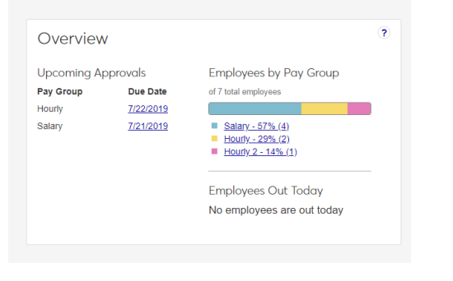
From the Hub click on the approve timecards. Click the + next to the employees name to review the time card. You can make changes from here.

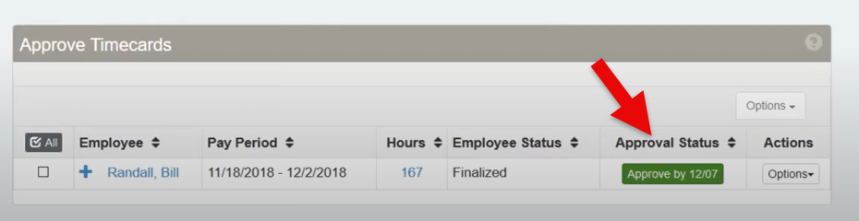

Short video for approving timecards:
https://www.youtube.com/watch?v=MbntKUBGJUg&list=PL6qAKxnxDmQkEMu6rsnQD6gLnm8kitIqu&index=13&pp=iAQB
Short video for assigning an alternate approver:
https://www.youtube.com/watch?v=NzxAP7jmtyc&list=PL6qAKxnxDmQkEMu6rsnQD6gLnm8kitIqu&index=14&pp=iAQB

