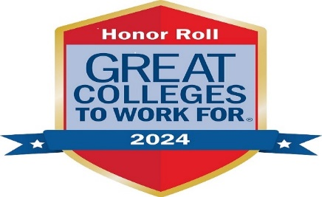

**Welcome to Your Human Resources Journey!**

* **Substance Free Workplace**
* **Workers’ Compensation**
* **Discrimination, Harassment, Retaliation including ADM 175 Pregnancy**

**Modifications Policy**

* **Mandated Reporting for Child Abuse and Neglect**
* **Any New Staff and Administrative Policy – ADM 412 Records Retention and Destruction Policy**

**Events Hosted by Your HR Office AY24/25:**

**January 2025 – TBS Community Awareness Circles**: One – hour Mental Health and Suicide Awareness circle for the MAC College Community Led by Carmen Zeisler from ESSDACK and in partnership with our college student population, may do a second circle later in the spring semester.

**January 30, 2025** – Brenda’s Good-Bye Bash – 11am to 1pm, Friendship Hall

**February 25, 2025 – 8 am to 10:30 am, All employee breakfast and program by ESSDACK presenting: The “River of Cruelty”** This metaphor describes how cruel behaviors move freely from person to person and through generations. It is well described as a “river,” as it flows from parent to child, influencing each generation. We did not have a choice when we landed in the “river.” We were “thrown in” before we were old or big enough to prevent it. Once in the “River”, we are often resourceful and develop skills that help us to survive.

**March 6, 2025 – Employee Service Awards Dinner and Program**

**Other Items Include:**

**Great College to Work for Survey 2024 update**

**2025 Insurance update**

**J1 employee payroll transition update**

**NOTE: All current employees will need to complete a new W4 and General Information sheet due to the upcoming J1 transition. Forms are available at the front reception desk in the Business Office. Friday, Dec 20, 2024 is the deadline to complete these forms.**

**Your McPherson College Personnel Committee reps are: Johnny Gilkey, Josh Nichols, Kelly Olson and Ashley Templeton**

**Human Resources - Open Office Hours: Monday & Thursday 2-5pm** [**hr@mcpherson.edu**](mailto:hr@mcpherson.edu)